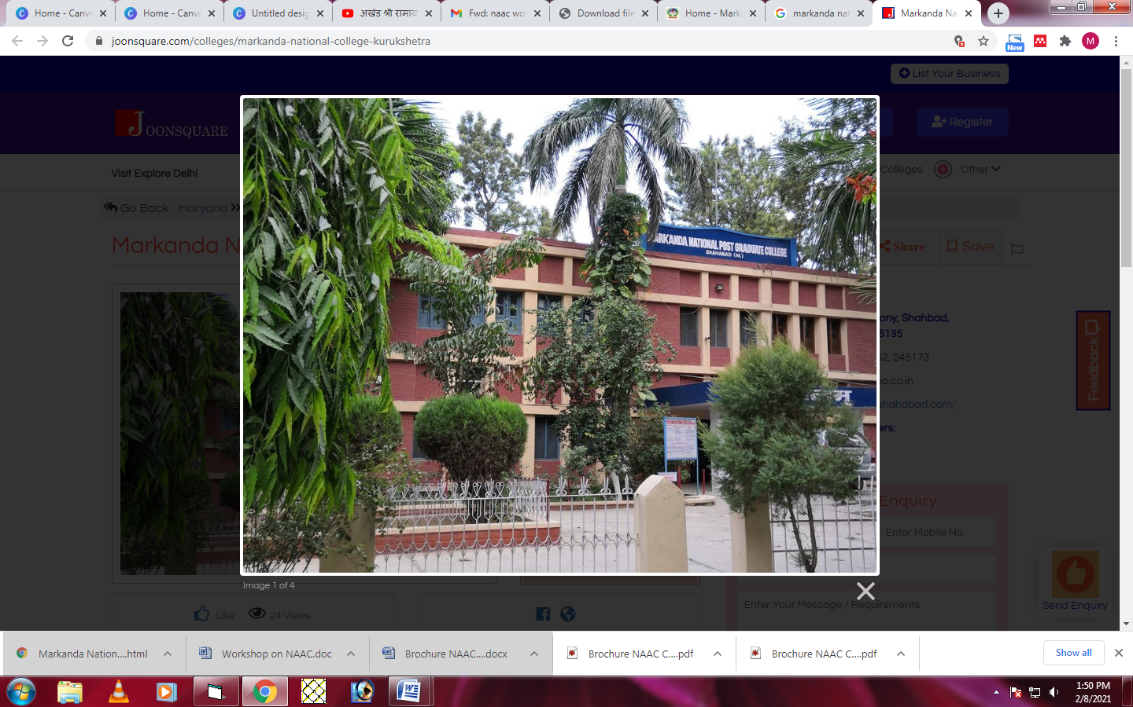

**PERSPECTIVE PLAN**

**2020-2025**

**Markanda National College**

***Ladwa Road, HUDA-1, Shahabad Markanda  
District Kurukshetra - 136135  
(Haryana) INDIA***

***http:/mncshahabad.com***

Contents

**About the College** 1

Perspective Plan 2

Planning for Curricular Aspects 3

Planning for Teaching Learning and Evaluation 4

Planning for Research, Innovation and Extension 5

Planning for Infrastructure and Learning Resources 6

Planning for Student Support and Progression 7

Planning for Governance, Leadership and Management 8

Planning for Institutional Values and Best Practices 9

# **About the College**

Markanda National College, Shahabad- Markanda was established in 1971 by M.N. College Educational Societyprimarily to cater to the educational needs of this predominantly rural area. At that time, no college existed in Shahabad and even at Kurukshetra - the seat of Kurukshetra University, except University College, which had onlybrilliant urban students on its rolls. The establishment of this college proved to be a boon for this area. Ever since its inception, this college has not looked back and making significant strides, it has developed into a multi-faculty institution, imparting instructions in English at Post-graduate level and in Arts, Science and Commerce Streamsat under- graduate level. The college also runs successfully PG diploma in Yoga and two job-oriented add-on courses(i) Retail Management and (ii) Information and Computer Technology. The college is a co- educational institution affiliated to Kurukshetra University, Kurukshetra and it is proud of its imposing infrastructure and an environment conducive to learning. It has a spacious building surrounded by lush green lawns and two playgrounds. The building consists of well-maintained class rooms, well equipped labs (Physics, Chemistry, Computer and EDUSAT), a spacious Library, a conference room, an auditorium with three green rooms, a seminar Hall, a big canteen, modern girls’ common room, besides office complex and Principal’s residence. Besides traditional subjects, faculty is available for teaching Marketing as vocational subject. The college is also runningNSS and NCC units successfully.

## VisioN

To impart Qualitative, Value-based and Employable education at affordable cost to all sections of the society and to make the college a “Total Quality Zone“.

## Mission

To pursue and disseminate knowledge with commitment to all sections of society.

To create and provide opportunities for the overall development of students.

To work towards optimum and meaningful utilization of human, infrastructural and financial resources.

To encourage self-evaluation, accountability and indigenous culture amongst the faculty members and students.

To foster the realization of social responsibilities and citizenship role amongst students.

To educate the girls of this semi-urban area at a very low cost and in a very dignified and secure atmosphere.

# Perspective Plan

The plan is envisaged to provide strategic planning and programmes to determine future course of action in dissemination of quality and value-based education to the pupils of the catchment area.

The objectives that are kept in mind while framing the perspective plan are as below:

1. To overhaul the present system with respect to automation and use of technology in education.
2. To raise the benchmarks to uplift the standard of imparting of education in the College.
3. To augment the infrastructure, curriculum and course outcomes of the College.
4. To expand the horizon of the college with respect to alumni network and placement of pupils.
5. To encourage holistic development of pupils with regard to development of physical capabilities, intellectual abilities, cognitive abilities, emotional abilities, and social skills etc.
6. To enable the students for critical thinking and creative problem-solving skills.
7. To inculcate value-based education through activities and volunteer services.

The IQAC considered the following inputs while designing the perspective plan:

1. Recommendations of Second Cycle NAAC Peer Team.
2. Core governing documents of the College – Vision and Mission Statements.
3. Inputs from Stakeholders.
4. SWOT Analysis of the College.
5. Advent of global competencies and demand of multiskilled human resources in corporate sector.
6. Multi and cross disciplinary approaches in education sector.

# Planning for Curricular Aspects

1. Preparation of academic calendar of the college and adherence to the same.
2. Preparation of Lesson Plans by the faculty and adherence to the same as per the course term.
3. Scheduled meetings of HOD’s for follow up actions.
4. Introduction of additional add-on certificate courses.
5. Curriculum reviewing at college level and passing on the same to the University.
6. Inclusion and integration of ICT based teaching in learning and development process.
7. Initiate more vocational courses and industry linked courses.
8. Introduction of new courses such as soft skills, ICT learning, TALLY, Functional English etc.
9. Preparation of College for implementation of New Education Policy.
10. Introduction of online feedback system from students in the form of Overall College Survey.
11. Conduction of periodic academic audits.
12. Strategic steps will be initiated to increase student enrollment ratio.

# Planning for Teaching Learning and Evaluation

1. The College will conduct and encourage the faculty members for faculty development programmes/seminars/conferences etc.
2. The College will conduct periodic training programmes for non-teaching staff in augmenting ICT skills and soft skills.
3. Explaining programme outcomes and course outcomes to students through orientation week sessions and mentorship classes.
4. Development of departmental libraries through donation or institutional resources.
5. Evaluation of teaching learning process
6. Introduction of latest ICT tools and techniques in teaching learning.
7. Introduction of training and informative sessions as part of career counselling and placement.
8. Signing of MOU’s with academic bodies and institutes to organize new courses and to gather expertise throughexchange programmes.
9. Organization of Industrial and Education tours to provide first-hand experience to students.
10. Creation of E-Content development centre in the College.
11. Gradual creation of smart classrooms/ICT infrastructure.
12. Identification of slow, mediocre and fast learners during orientation week and framing of extra classes as per need basis.
13. Conduction of bridge courses for new entrants.
14. More emphasis will be laid on collaborative learning than on monologue teaching.
15. Introduction of more robust remedial teaching.

# Planning for Research, Innovation and Extension

1. Signing up of MOU’s with institutions of repute to enhance research activities in the college.
2. To enhance Collaborations/Linkages with different industries, institutes for research, field projects, student trainings, teacher training and exchange to create more opportunities for the students.
3. Encouragement to faculty to get major/minor projects from Government/Non-government Organisations.
4. Organisation of at leastone international level conference/seminar per year along with regular practice of national conferences/seminars.
5. Promote a culture of quality publication among faculty members.
6. Encouragement of consultancy services through faculty members to local population or to any other entity.
7. Active involvement of students in research and extension activities.
8. Community outreach programmes will be initiated by providing makerspace to budding entrepreneurs.
9. Opening up of resources for the local population in the form of free usage of resources, external membership with free or nominal fees and/or paid services.
10. Active association of various student cells of the college with the persons associated with literature, arts, science, commerce, tradeetc.;who have proved their mettle through creativity, diligence, dedication and have benefitted humankind and environment in the catchment area.

# Planning for Infrastructure and Learning Resources

1. To build 3 classrooms with state-of-the-art technological tools.
2. Digital communication will be encouraged with least usage of paper.
3. Enhancing the capacity of existing computer labs.
4. Full Automation of Library.
5. Working Lab for Commerce students.
6. Audio-Video E-Learning lounge will be developed.
7. Medical facilities will be augmented and exigencies will be dealt with medical support from hospitals in the vicinity.
8. Staff rooms and Departments will be furnished with IT/Operational infrastructure.
9. Construction of restrooms and other divyangjan facilities.
10. Development of leaf composters in the Campus.
11. Establishment of Rain water harvesting system in the Campus.
12. To conduct green and energy audit of the Campus.
13. Enhancement of existing facilities of Girls common room.
14. E-waste will be discarded as per the Govt. policy.
15. Addition of facilities for robust online examination and evaluation system.

# Planning for Student Support and Progression

1. To increase the enrollment of students.
2. To establish Student Council at the College level to provide a platform for leadership traits and communication of students’ issues.
3. To empower Student Council to conduct various programmes through student body only.
4. To strengthen the Career counselling and training through placement cell.
5. To develop industry-academia interaction through visits and talks of experts.
6. To conduct, if feasible, competitive exams coaching in the College.
7. To establish and strengthen clubs/cells/associations of the College.
8. To conduct competitions on niche topics at State/National/International levels.
9. To organize Sports Activities/Yoga /Road Safety/ Blood Donation Camps etc. in the College.
10. To felicitate toppers/achievers by the Alumni Association.
11. To register Alumni Association and organize get-together annually.
12. To setup entrepreneurship centre in Campus.

# Planning for Governance, Leadership and Management

1. Vision and Mission of the College will be communicated among the stakeholders.
2. Faculty will be encouraged to attend Faculty development programmes.
3. Efforts will be made to fill vacant faculty positions.
4. Staff Welfare schemes will be initiated.
5. Alumni will be approached for endowments for various departments and facilities of the College.
6. Funding agencies will be approached for grants under various schemes and plans for the development of College.
7. To complete the NAAC IIIrd Cycle of Accreditation.

# Planning for Institutional Values and Best Practices

1. To make mentorship classes a regular practice.
2. To organize spiritual, motivational and character-building lectures in the College.
3. To remodel adopted village with the help of NCC/NSS units.
4. To conduct activities in collaboration with NGO’s.
5. Establishment of Disaster Response Club in the college.
6. More Energy and Green Eco initiatives.
7. To support Government in community projects.
8. To initiate optimum use of ICT in teaching and administration.
9. To maintain plastic free campus.
10. To conserve environment and energy through various drives by involving community.